Casey First Christian Church (Disciples of Christ)
200 SE 8th St. · P.O. Box 303 · Casey, IL 62420
(217)932-2773 · cfcc@caseyfcc.org · www.caseyfcc.org

Sunday Services: 9:00 am Sunday School · 10:00 am Worship

To Know God-To Love God-To Serve God

SERVING SCHEDULE
 | Week  12/01/2019 | Week  12/08/2019 | Week  12/15/2019 | Week  12/22/2019 | Week  12/29/2019
ELDERS | Debi Sinclair | Dan Winn | Sharon Durham | Nina Meeker | Moe Wimbley
ELDERS SHUT-INS | Debi Sinclair
DEACONS | Jeanne Unzicker  Jeri Bland  Bill Brewer | Brad Hickox  Charles Meeker  Cassie Ramsey | Sharon Richardson  Connie Roberts  Shellie Simpson | Kenny Shobe  Steph Shobe  Devan Smith | Cheryl Stifal  Jeanne Unzicker  Jeri Bland
PREP. COMM. | Jeanne & Jeri | Brad & Charles | Sharon & Connie | Kenny & Steph | Cheryl & Jeanne
DEACONS SHUT-INS | Jeanne & Jeri
WORSHIP LEADER | Larry Patchett | Peggy Hickox | Kathy Hayes | Ruthie Wimbley
GREETER | Linda Stoneking | Eleanor Markwell | Ruthie Wimbley | Rose Peterson | Linda Coleman
SOUND | Devan Smith | Ken Whitton |  | Brad Hickox | Devan Smith
CHILDREN'S MESSAGE | Rev. Mike | Peggy Hickox | Rev. Mike | Rev. Mike | Ruthie Wimbley
CHALLENGER REFRESHMENTS | Grahams | Peggy Hickox | Eleanor Markwell | Larry Patchett | Cathy Sherwood
SERMON | Rev. Mike Dixon | Rev. Mike Dixon | Rev. Mike Dixon | Rev. Mike Dixon | Christmas Hymns
IF YOU ARE UNABLE TO FULFILL YOUR RESPONSIBILITY, IT IS UP TO YOU TO FIND A REPLACEMENT.
Prayer Requests
Knighton Clark – Grandson of Barb Decker’s Sister, Stella Donaldson
Larry Cutright
Jim Davidson
Karon Davis
Shirley Fitch – Surgery went well, prayers for recovery & therapy
Tricia Garver – Knee replacement went well, prayers for recovery & therapy
Donna Hacker, Nina Meeker’s Sister, Diagnosed with ALS
Becky Hardway – Iris McComas’ Daughter
Jeanne Hardway – Steph Shobe’s Cousin
Donna Hellman – Jeanne Unzicker’s Sister
Stephanie Nichols – Prayers for recovery & therapy from back surgery
Randy Rue
Shawn Stifal & his Family- Shawn’s surgery went well, Dr. appt. Nov. 20th for results

Our Sympathy and Condolences to the following families that have lost loved ones since the last newsletter.

Family of Jack Gilbert – Kathy Hayes’ Uncle
Family of Archie Gowin
Family of Lawrence McKinney
Family of Donnie Maulding - Father of Lori Dvorak, Ron & Jason.
Family of Sandra Kuchar – Rose Peterson’s Sister-in-law
Family of Roger Icenogle – Eleanor Markwell’s Brother
Family of Paul Hawker
Protz Family – Auto Accident, Vandalia & Sullivan Families

JOYS
Rev. Mike & Peg Dixon – New Granddaughter
Barb Decker – Good report with the Doctor
Brent & Courtney Shobe expecting a baby in April, Anxious Grandparents – Kenny & Steph

Casey Health Care Heartland Nursing Active Military
Ruth Fitch & Rehabilitation Tyler Rue
Vera Ingle
Arbor Rose Memory Care Helen Allen
Brenda Whitton Allen Boyd

Announcements & Upcoming Events

ACTIVITIES IN THE CHURCH

Nov 20 7:00 pm Elders Meeting (Date change due to Thanksgiving)
Nov 21 9:30 am Worship Team Meeting
Nov 28 “Happy Thanksgiving!” – Church Office Closed
Nov 29 Church Office Closed
Dec 1 Hanging of the Greens
Dec 4 7:00 pm Board Meeting
Dec 5 2:00-5:00 pm 4-H Banquet in Fellowship Hall
Dec 8 1-5 pm Fellowship Hall Rented for Birthday Party
Dec 11 6:30 pm Dinner & A Prayer
Dec 14 9:00 – 11:00 am Kids’ Christmas Shop
Dec 16 10:00 am Meet to put food bags together at Hutton Bldg.
Dec 17 12:30 pm Hand out Food Pantry Bags at Hutton Bldg.
Dec 18 7:00 pm Elders Meeting
Dec 24 7:00 pm Christmas Eve Service
Dec 25 CHRISTMAS DAY – “HAPPY BIRTHDAY, JESUS!”
2020 Jan 4 McCash Family Christmas in Fellowship Hall
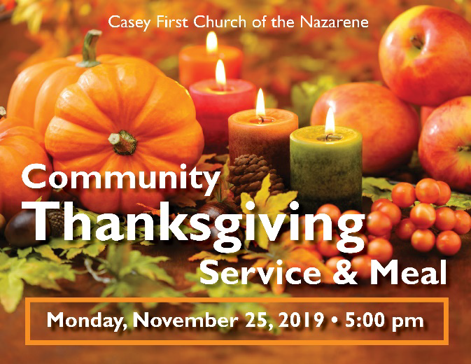

The Community Christian Toy Fund is in need of donations; money, food for the food baskets or toys. All donations need to be received by Dec. 15th for delivery to the families on Dec. 19th.
Contact Ed Richardson 932-4384 or Sharon Carlen 932-2136 with questions. Monetary donations can be mailed to
Community Christian Toy Fund,
C/O Ed Richardson,
401 NE 2nd Street, Casey, IL 62420

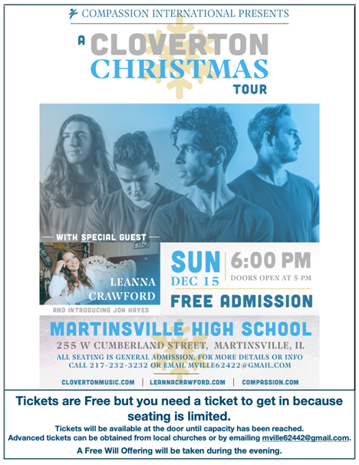

Dinner & A Prayer for Women, Wednesday, December 11th @ 6:30 pm
in the Fellowship Hall. Watch for details.

December 2019

1 – Blake Ramsey 16 – Ed & Marge Allen
2 – Ed Allen 19 – Curt Wheat
4 – Marge Allen 23 – Randy & Rebecca Daugherty
7 – Kenny Whitton 27 – Audrey Sherwood
7 – Dan Winn 28 – Carole Cutright
10 – Gene Whitton 30 – Kyleigh Decker
14 – Moe Wimbley 30 – Olive Athey

 | December 2019
Sunday | Monday | Tuesday | Wednesday | Thursday | Friday | Saturday
1  Hanging of the Greens | 2 | 3 | 4  7:00 pm Board Mtg. | 5  4-H Banquet FH 2-5 pm | 6 | 7
8  1-5 pm FH Rented  BD Party | 9  MML  9:00 AM | 10 | 11  6:30 pm  Dinner & A Prayer FH | 12 | 13 | 14  9-11 am  Kids’ Christmas Shop
15 | 16  MML  9:00 AM  Food Bank  Prep | 17  Food Bank  Hand Out | 18  7:00 pm Elders Mtg. | 19 | 20 | 21
22 | 23  MML  9:00 AM | 24  7:00 pm  Christmas Eve Service | 25  CHRISTMAS DAY  Office Closed | 26 | 27 | 28
29 | 30  MML  9:00 AM | 31
MML – Monday Morning Ladies
FH – Fellowship Hall
Sunday School 9:00 am, Worship 10:00 am

