Casey First Christian Church (Disciples of Christ)
200 SE 8th St. · P.O. Box 303 · Casey, IL 62420
(217)932-2773 · cfcc@caseyfcc.org · www.caseyfcc.org
Pastor Evan Sherar, 812-698-7504, pastor.evansherar@gmail.com
Pastor Office Hours: Monday10 am-4 pm, Tues-Thurs 9 am-2 pm
Secretary Office Hours: Wednesday 8:00 am - Noon
Sunday Services: 9:00 am Sunday School, 10:00 am Worship

To Know God-To Love God-To Serve God

For greater context, I invite you to go and read Acts 8:26-40 in whatever translation of your
choosing. But I want to focus in on verses 36 through 38 (including verse 37, which some critical
editions put in a footnote because many ancient manuscripts do not have it). Here is the NRSV
Updated Edition:
36 As they were going along the road, they came to some water, and the eunuch said, “Look,
here is water! What is to prevent me from being baptized?” 37 And Philip said, “If you believe
with all your heart, you may.” And he replied, “I believe that Jesus Christ is the Son of God.” 38
He commanded the chariot to stop, and both of them, Philip and the eunuch, went down into the
water, and Philip baptized him.
In this story, Philip encounters a eunuch and shares with him the Gospel of Jesus Christ. The
eunuch asks if there is any reason he couldn’t be baptized - that is fully included without
reservation - and Philip says the only condition for full inclusion is that he believe with all his
heart. The eunuch then declares something strikingly similar to the christological confession that
Peter gives in Matthew 16:16 - “You (Jesus) are the Christ, the son of the living God.” Philip
then baptizes the eunuch. This is an act of radical inclusion. And I think this example is vitally
important for Christians today, and especially during this month of June where many celebrate
LGBTQ Pride.
In the ancient world, a eunuch would have been considered a sexual minority. They did not fit
neatly into the world’s expectations of gender and sex. They did not really fit into the category of
either “man” or “woman.” Some were people who were born with both male and female
characteristics. Some would choose to become eunuchs because this was what they felt was
the best representation of who they were on the inside. Others, like the eunuch in this story in
Acts, were servants in a royal court, trusted by queens and other female nobles with “womanly”
matters that men did not usually get involved with. This eunuch may have been kind of like the
queen’s “gay best friend.”
Eunuchs also, because they did not fit into the “accepted” norms, would have been totally
excluded from worship in the Temple in Jerusalem, and really many temples throughout the
ancient world. They would not have been allowed to enter the main sanctuary where people
came to worship God. There were some rooms where they were allowed, on a conditional
basis, but never with full status. They would have been kept out of the holiest places, and told
that because of who they were they were unclean, unholy, and that they did not belong among
the people of God.
Eunuchs were a social taboo. And much of how eunuchs were treated aligns with how the
Church has often treated lesbians, gay, bisexual, and transgender people today. Some consider
LGBTQ people to be demonic and evil. Some use the term “abomination” or say homosexuality
is “incompatible with Christian practice.” During the HIV/AIDS epidemic of the 80’s and 90’s, gay
and trans people were shunned, many denied medical care, denied religious funerals, denied
burial in church-owned cemeteries. On the better end of things, sometimes these people are
welcomed into churches, and allowed to attend worship services. But sometimes even churches
who say “All are welcome,” have strings attached. They can attend, but their marriage isn’t a
“real” marriage. They can attend, but they can’t be in leadership. They are welcome to be here,
but we do not condone their “lifestyle.”
But what does Philip do when he encounters a eunuch? What happens with Philip, one of
Jesus’ earliest disciples who spends years of his life traveling and ministering with Jesus
through all of his earthly ministry, encounters this person who did not conform to social norms
regarding gender and sexuality? What does Philip do? He does something that would have
been considered radical. He baptizes him.
By baptizing this eunuch, Philip totally affirms him as a beloved child of God. Being baptized,
this eunuch is fully and without restriction or secondary status included in the family of God.
Philip does not ask the eunuch to repent or change from being a eunuch. He does not condemn
his “lifestyle” or deny him access to holy places. Philip practices radical welcome, radical
inclusion. In many ancient manuscripts, Philip does not even require anything from the eunuch,
not even an explicit declaration of faith. But I think this verse 37 is important because in it, this
eunuch confesses the same statement that Peter makes about Jesus - that he is the Christ and
the Son of God. This is the foundational confession of Christian faith, the rock on which Jesus
says his church is built. And for it to come from the mouth of a eunuch - an outcast, a queer
person, someone considered unholy and unclean - is a radical affirmation of their belovedness
in Christ.
I think Philip’s example should be one we, Christians, take seriously today regarding the LGBTQ
community. At the very least it should give us pause when some use the words “abomination” or
“sin” regarding homosexuality and transgender identity. It should challenge our assumption that
this is something new that this younger generation has come up with. It should call us to
examine the ways we have traditionally responded to this community, and it should inspire us to
imagine something better. Imagine a world where Jesus’ radical love reigns in all aspects of our
lives. How might God be calling us to love our LGBT neighbors today?
And if this newsletter happens to find it’s way into the hands of an LGBTQ+ person, even here
in Casey, IL or greater Clark County - yes even here! - I want you to know that God loves you.
God loves you, God loves you, God loves you. Without condition or exception. God’s love is for
you. You are holy, beautifully and wonderfully made, exactly as God has made you. God made
you this way for a reason. Your joy is good and holy. You relationships are holy. Who you truly
are is holy, sacred, and beloved. Above all, whatever you’ve heard and whatever you’ve
experienced, I pray that you can know in the deepest part of your soul: God loves you.
Grace and peace,
Pastor Evan

Prayer Requests
Larry Patchett Doris Taylor
Kenny & Steph Shobe Ralph Fitch
Deb Decker Dorothy Stice
Barb Decker Trudy List

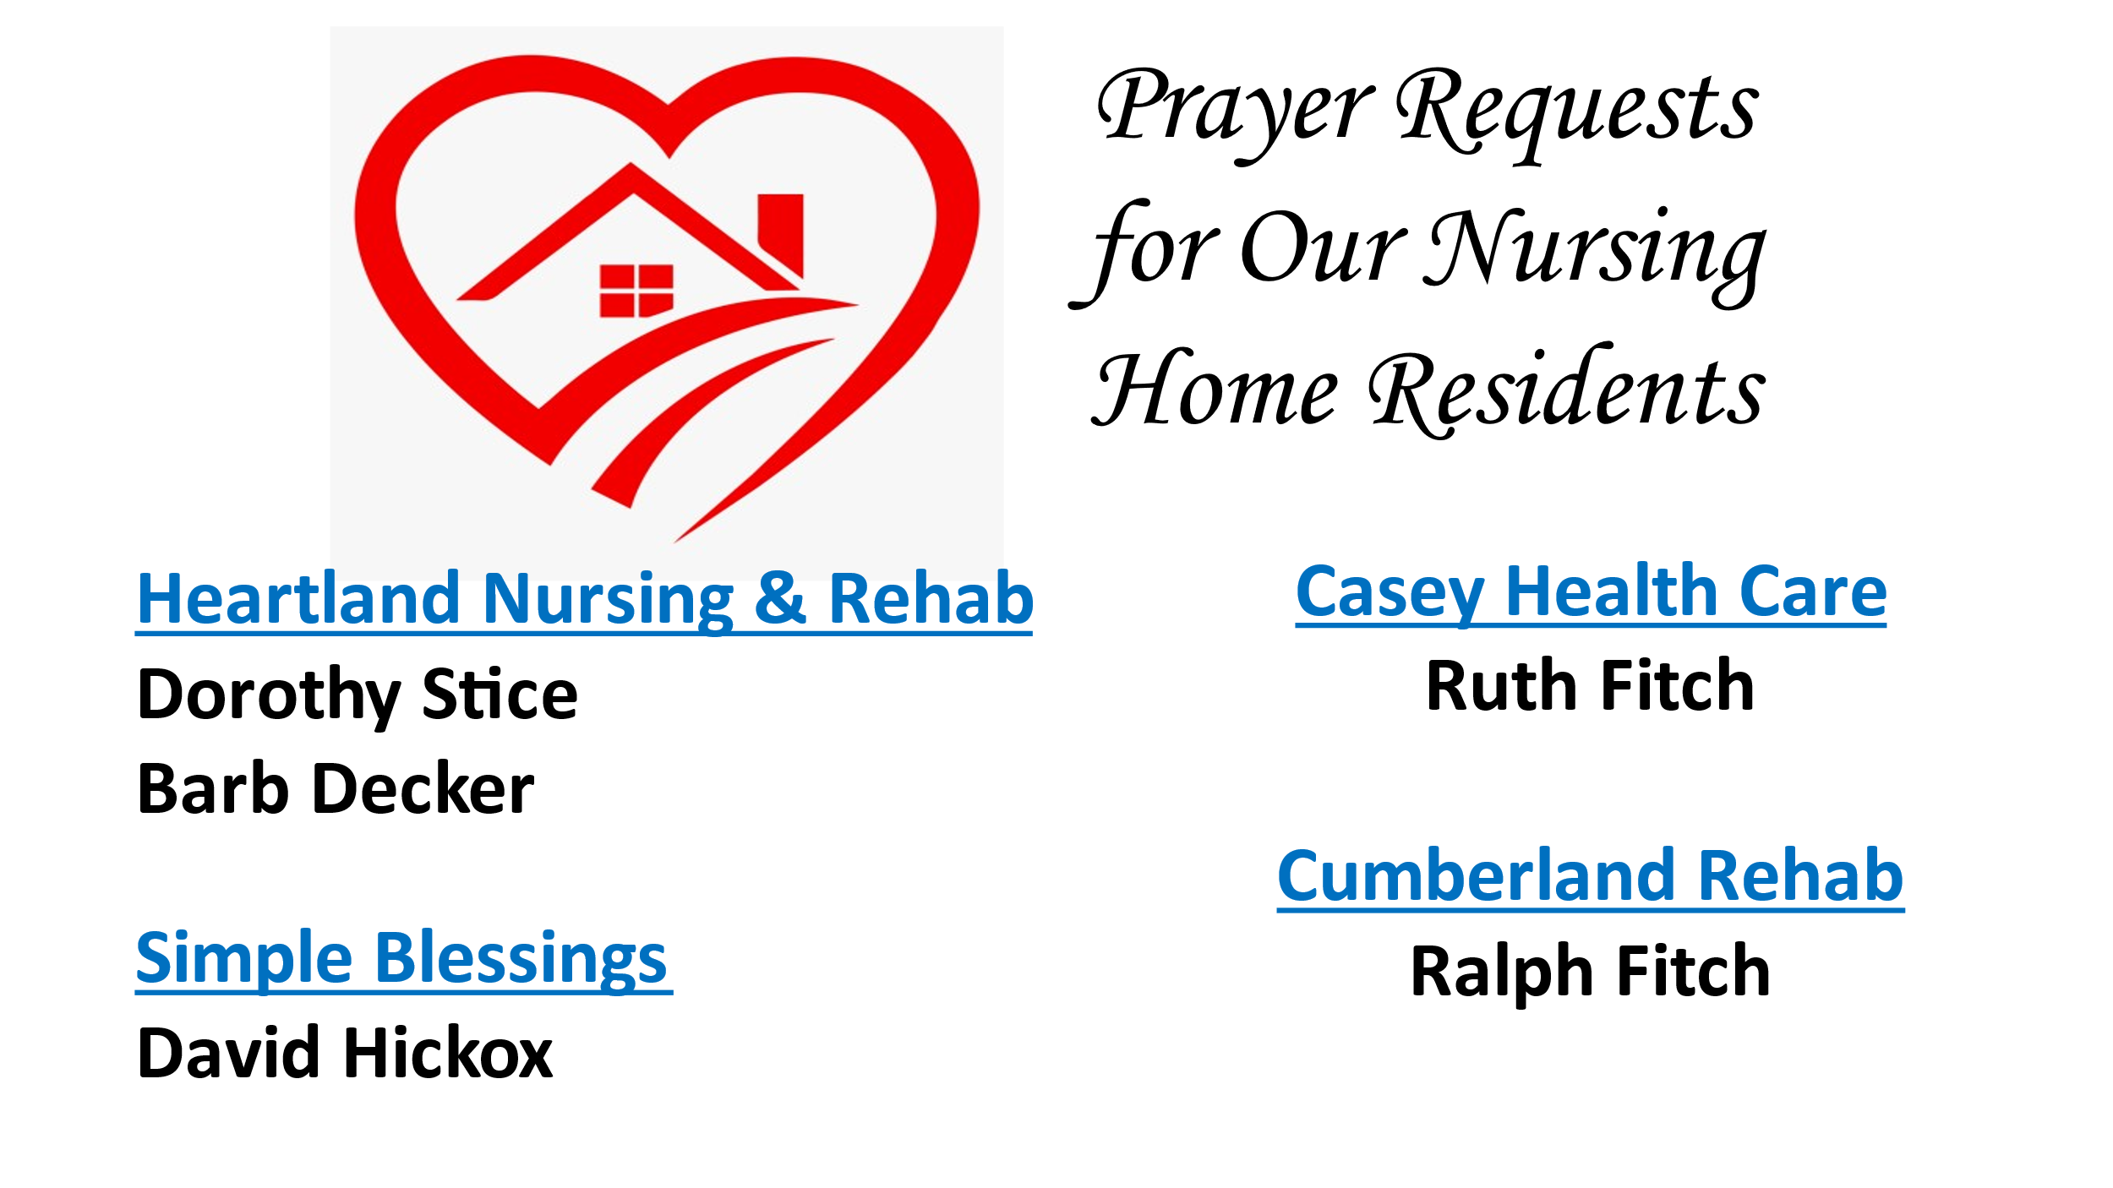

JUNE SERVING SCHEDULES

ELDERS: 6/4 Kathy H, 6/11 Peggy H, 6/18 Nina M, 6/25 Debi S
DEACONS: 6/4 Becky S, Jeanne U, Michelle W, 6/11 Jenny W, Lynda G, Brad H,
6/18 Cassie R, Connie R, Cathy S, 6/25 Shellie S, Devan S, Cheryl S
CHALLENGER REFRESHMENTS: 6/4 Debi S, 6/11 Linda S, 6/18 Sherri B, 6/25 Linda C
SOUND TECHS: 6/4 Ken W, 6/11 Cathy S, 6/18 Dyson W, 6/25 Brad H

Announcements & Upcoming Community Events

May 31, 2023, Wednesday, 6:30 pm Elders Meeting
June 3, 2023, Saturday, Fellowship Hall reserved in the afternoon
June 7, 2023, Wednesday, 6:30 pm Board Meeting
June 18, 2023, Sunday, “HAPPY FATHER’S DAY!”
June 18, 2023, Sunday, Pastor Evan’s last Sunday
June 18, 2023, Sunday, Rev. Alex Ruth will be our guest.
June 21, 2023, Wednesday, 9:30 am Worship Team Meeting
June 28, 2023, Wednesday, 6:30 pm Elders Meeting

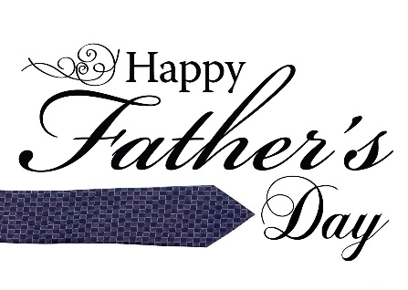
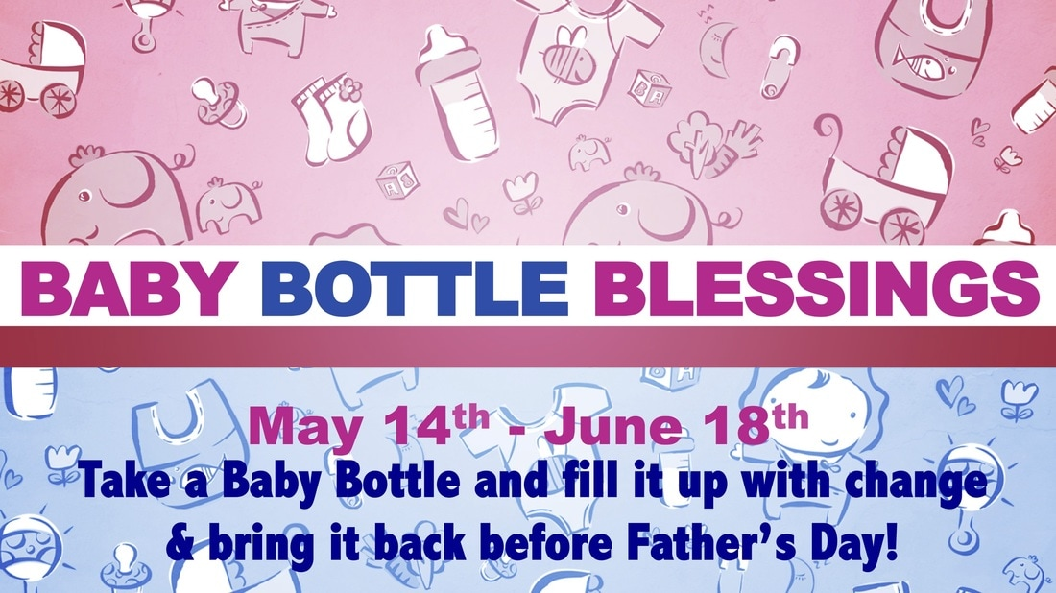
Sunday, June 18th

JUNE 2023

3 – Mike Hayes 20 – Jenny Winschief
8 – Katie Sherar 22 – Nina Meeker
9 – Scott & Cheryl Stifal 23 – Mike & Cathy Sherwood
11 – Chris & Jenny Winschief 25 – Roberta Decker
12 – Charles Meeker 25 – Pastor Evan Sherar
19 – Sherri Butcher 26 – Mike & Kathy Hayes
19 – Dan & Darlene Winn

 | JUNE 2023
Sunday | Monday | Tuesday | Wednesday | Thursday | Friday | Saturday
 |  |  |  | 1 | 2 | 3  Afternoon  FH Reserved
4  Elder: Kathy H | 5  MML 9 am | 6 | 7  6:30 pm  Board Mtg. | 8 | 9 | 10
11  Elder: Peggy H | 12  MML 9 am | 13 | 14 | 15 | 16 | 17
18  Elder: Nina M | 19  MML 9 am | 20 | 21  9:30 am  Worship Team Mtg | 22 | 23 | 24
25  Elder: Debi S | 26  MML 9 am | 27 | 28  6:30 pm  Elders Mtg. | 29 | 30
FH – Fellowship Hall
MML – Monday Morning Ladies
SUNDAYS
9:00 am Sunday School, 10:00 am Worship

