Casey First Christian Church (Disciples of Christ)
200 SE 8th St. · P.O. Box 303 · Casey, IL 62420
(217)932-2773 · cfcc@caseyfcc.org · www.caseyfcc.org

Sunday Services: 9:00 am Sunday School · 10:00 am Worship

To Know God-To Love God-To Serve God

SERVING SCHEDULE
 | Week  10/6/2019 | Week  10/13/2019 | Week  10/20/2019 | Week  10/27/2019 | Week  11/03/2019
ELDERS | Moe Wimbley | Sharon Durham | Debi Sinclair | Dan Winn | Sharon Durham
ELDERS SHUT-INS | Moe Wimbley |  |  |  | Sharon Durham
DEACONS | Bill Brewer  Brad Hickox  Charles Meeker | Cassie Ramsey  Sharon Richardson  Connie Roberts | Kenny Shobe  Steph Shobe  Shellie Simpson | Devan Smith  Cheryl Stifal  Jeanne Unzicker | Jeri Bland  Bill Brewer  Brad Hickox
PREP. COMM. | Bill & Brad | Cassie & Sharon | Kenny & Steph | Devan & Cheryl | Jeanne & Jeri
DEACONS SHUT-INS | Bill & Brad |  |  |  | Jeanne & Jeri
WORSHIP LEADER | Peggy Hickox | Debi Sinclair |  | Devan Smith | Larry Patchett
GREETER | Ruthie & Moe | Dorothy Stice | John & Lynda Graham | Jan Richardson | Marsha Rue
SOUND | Devan Smith | Ken Whitton |  | Brad Hickox | Devan Smith
CHILDREN'S MESSAGE | Rev. Mike | Rev. Mike | Rev. Mike | Rev. Mike
CHALLENGER REFRESHMENTS | Eleanor Markwell | Larry Patchett | Cathy Sherwood | Debi Sinclair | Linda Stoneking
SERMON | Rev Mike | Rev. Mike | Rev. Mike | Rev. Mike
PLEASE FIND A REPLACEMENT IF YOU ARE NOT ABLE TO SERVE.
UPDATED SERVING SCHEDULES ARE ON THE TABLE IN THE GATHERING ROOM.
Prayer Requests
Barb Decker
Cecil Dixon – Rev. Mike’s Dad
Ralph & Shirley Fitch
Donna Hacker
Vera Ingle
Liza Marie Johnson – Baby Daughter of Andy & Kelly Johnson, Granddaughter of Mike & Cathy Sherwood
Randy Rue
Dave Sauer
Arden Shaffner

Our Sympathy and Condolences to the following families that lost loved ones this past month.

Stephen Davis Family
Nick Hopkins Family
Wanda McNary Family

JOYS

Dr. T.L. Butcher
40 Years Ago – 1979
Opened his chiropractic service in Casey on
North Central Avenue

Casey Health Care Heartland Nursing Active Military
Ruth Fitch & Rehabilitation Tyler Rue
Vera Ingle
Arbor Rose Memory Care Helen Allen
Brenda Whitton

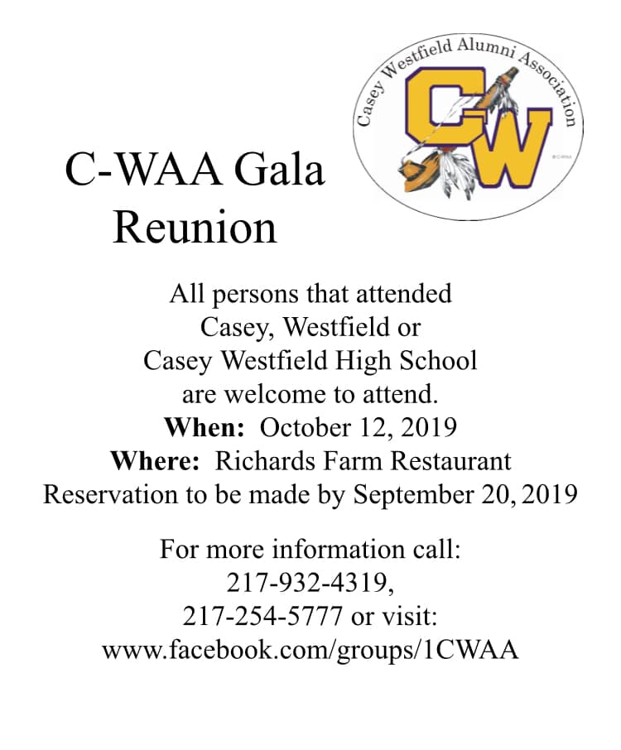

Announcements & Upcoming Events

We are Invited to the
Casey First Baptist Church
Sunday, Sept. 22nd at 6:00 pm
for an evening of musical worship and praise featuring the
HOMECOMING GOSPEL CHOIR
They are a southern Illinois 80-voice gospel choir under the direction of John and Judy Roberts. They will be singing your favorite southern gospel songs and hymns in the Gaither style.

NOTICE FROM NOMINATING TEAM FOR 2020 BOARD MEMBERS
The Nominating Team is accepting names for church board offices. If any member of the church is interested in running for an office or if you have a candidate in mind, please contact a member of the nominating team. All names will be presented to the Board
October 2, 2019.
The Nominating Team are; Sharon Durham, Brad Hickox, Nina Meeker, Cathy Sherwood & Darlene Winn

POPCORN FESTIVAL
Thank you church family for all of your help during the Popcorn Festival. We could not have done it without all of you. Sherri
Proceeds $2,530.53

IGA COOKOUT FUNDRAISER
The cookout was a great success. Thank you to all who helped in any way.
Proceeds were
$540.13

With sincere appreciation I want to say “Thank You!” to all who helped with the Popcorn Festival Booth. Thanks to those who stepped up and agreed to take charge, to the bakers, to those who gave of their time to work in the booth and especially those who helped with the very big job of setting up the booth and taking it down. Too many to name but you know who you are. Nina

Macedonia Baptist Church
is hosting a “Ladies Day Out”.
Saturday, October 5th, 1:00 pm
Meet author & speaker,
Jeanette Levellie!
“Need a Splash of
Hope from God’s Heart?”
Call 217-218-4597 for more details.
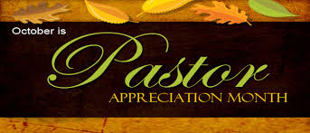

“SPREAD THE WORD”
NOVEMBER 10TH DURING THE 10:00 AM WORSHIP SERVICE
THE OPEN HEART GOSPEL QUARTET
WILL BRING OUR WORSHIP SERVICE IN MUSIC
THEY ARE FROM THE BEDFORD, INDIANA AREA
Open Heart Quartet is a group of Christian men who love the Lord with all their heart and it comes through in the music that they sing. Each song ministers in it's own special way with harmonies that are so anointed and powerful. To God be glory!
PLEASE COME JOIN US SUNDAY MORNING, NOVEMBER 10TH
AND BRING YOUR FAMILY & FRIENDS!

ACTIVITIES IN THE CHURCH

Sep 25 7:00 pm Elders Meeting
Oct 2 7:00 pm Board Meeting
Oct 9 6:30 pm Dinner & A Prayer
Oct 14 COLUMBUS DAY-CHURCH OFFICE CLOSED
Oct 24 9:30 am Worship Team Meeting
Oct 30 7:00 pm Elders Meeting
Oct 31-Nov 2 Clapp/Glidewell Decorating, Rehearsal & Wedding
Nov 3 Time Change, FALL BACK, turn your clocks back 1 hour
Nov 5 12:00 – 6:00 pm Blood Drive here at CFCC
Nov 10 10:00 am During Worship - Open Heart Gospel Quartet

October 2019

4 - Kora Smith 13 – Brock Athey
6 – Cheryl Freeman 19 – Curtis & Karen Carver
6 – Jason Clapp 24 – Ralph Fitch
9 – Dennis & Marsha Millam 26 – Ashton Newlin
13 – Echo Sherwood 29 – Mike Leichty

SEPTEMBER 23RD

 | October 2019
Sunday | Monday | Tuesday | Wednesday | Thursday | Friday | Saturday
 |  | 1 | 2  Board Meeting  7:00 pm | 3 | 4 | 5  FH Rented
6  World Communion Sunday | 7  MML  9:00 AM | 8 | 9  Dinner & A Prayer  6:30 pm | 10 | 11 | 12
13 | 14  MML  9:00 AM  Church Office closed for Columbus Day | 15 | 16 | 17 | 18 | 19
20 | 21  MML  9:00 AM | 22 | 23 | 24  Worship Team Meeting 9:30 am | 25 | 26
27 | 28  MML  9:00 AM | 29 | 30  Elders Meeting 7:00 pm | 31  Church being decorated for wedding
MML – Monday Morning Ladies
FH – Fellowship Hall
Sunday School 9:00 am, Worship 10:00 am

