Casey First Christian Church (Disciples of Christ)
200 SE 8th St. · P.O. Box 303 · Casey, IL 62420
(217)932-2773 · cfcc@caseyfcc.org · www.caseyfcc.org
Rev. Jacqueline Morgan, Pastor · (217)549-0654

Sunday Services: 9:00 am Sunday School · 10:00 am Worship

To Know Him-Love Him-Share Him

_________________________________________________________________________________________
SERVING SCHEDULE
 | Sept 2nd | Sept 9th | Sept 16th | Sept 23rd | Sept 30th
ELDERS | 10:00 AM | Ken Whitton Nina Meeker | Kathy Hayes  Cindy Stephen | Sherri Butcher  Larry Patchett | Ken Whitton Moe Wimbley
ELDERS SHUT-INS | SERVICE
DEACONS | AT THE | Kenny Shobe  Steph Shobe Shellie Simpson | Devan Smith  Cheryl Stifal  Jeanne Unzicker | Marcia Vidoni  Jeri Bland  Charles Meeker | Bill Brewer Linda Coleman Cassie Ramsey
PREP. COMM. | PARK | Kenny & Steph | Cheryl & Jeanne | Jeri & Charles | Linda & Cassie
DEACONS SHUT-INS | -----
WORSHIP  LEADER | NO | Bill Brewer | Jeri Bland | Steph Shobe | Kathy Hayes
GREETER | SERVICES | Roberta Decker | John & Lynda | Peggy & Brad | Larry Patchett
SOUND | AT THE | Brad Hickox | Ken Whitton | Michael Stephen | Brad Hickox
CHILDREN'S MESSAGE | CHURCH | Patty Clapp | Bill Brewer |  | Kathy Hayes
CHALLENGER REFRESHMENTS |  | Sharon Durham | John &Lynda G. | Peggy Hickox | Eleanor Markwell
SERMON |  | Pastor Jacqueline | Pastor Jacqueline | Pastor Jacqueline | Pastor Jacqueline

From the pastor’s desk…

Sometimes it seems like the bad news and the bad things just don’t stop coming. Health problems, losses, family quarrels, economic stresses, etc., etc. are overwhelming and debilitating. It is in times like these that we often feel forsaken and abandoned. If you are anything like me, when those times hit, you want to just crawl under the covers and never come out again. But it is usually when we resurface that we find the arms of God waiting for us in the form of the people who love us and are there for us; able and willing to walk with us through the dark valleys and give us support on the way back up the mountain.

And sometimes things are just honkey-dory in our lives and we witness the devastation happening in the lives of others and we feel helpless, not knowing what to do or how to be of any kind of support. Maybe we have some words of wisdom, hugs, time, material things and our presence to share, but aren’t sure when the right time is to share them.

As a church family, we do the best we can and from what I have witnessed so far, we do a pretty good job at even though we are not perfect. Sometimes when we have a good thing going on, we are not good at sharing it outside of our own circles. Our Regional Church is taking on a new initiative to help create supportive bonds beyond the walls of our individual congregations to share encouraging words with one another. It is called: “A Call to Socialize.” This Call encourages us to participate in 3 different ways:

- Visit cciwdisciples.org and sign up for the CCIW e-newsletter. This is great way to stay informed of what is going on in the Region.
- Join the forum discussion on the web by visiting socialize.cciwdisciples.org and look for the discussion of the day, or the one that might lift you up and share your thoughts
- Join the Region on Facebook at cciwdisciples

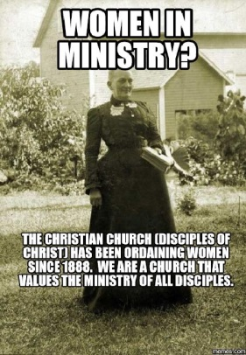
In these different ways and with small steps we can connect in new ways that we couldn’t before. And maybe one day when we are having a tough day, we might read something on one of those places that brightens our day, gives us hope and puts a smile on our face again. It did for me this week!

Blessings,
Jacqueline

Prayer Requests
June Athey
Bob Bluhm
Loretta Boyd
Patty Clapp
Ron Cochran
Rebecca Daugherty
Dale Finney
Rich Grafton
Lowell Hickox

Shawn Stifal
Ted Stivers
Bob William
Darlene Winn
Kay Hunsaker family
Brianna Athey family
Janet Cooper family
Steve Vickroy family
Rube Howe family

Sue Hills
Sue Liffick
Leo Perisho
Randy Rue
Ron Rue
Anna Schlacter
Jerry Self
Kenny Shobe
Addie Squires

Casey Health Care Heartland Active Military
Patty Hickox Vera Ingle Brandon Blair
Ruth Fitch Simple Blessings Daniel Daugherty
Laura Snider Mitchell Markwell

Thank you First Christian Church for opening your church to our family and friends for Brianna’s service. We are truly blessed to live in such a great community!
Rick & Carlotta Athey
Brock & Lara, Sara, Rhett, & June Athey
Bryant & Ashley, Blair & Brecken Athey

Announcements & Upcoming Events

Kleenex & Puffs boxes for Monroe Elementary School
We have collected 113 boxes of tissue!!! Thank you to all who donated!
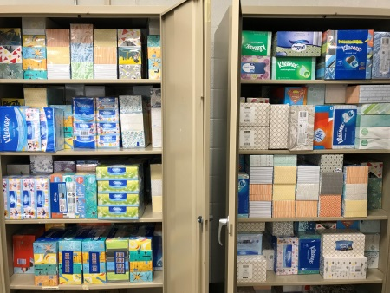
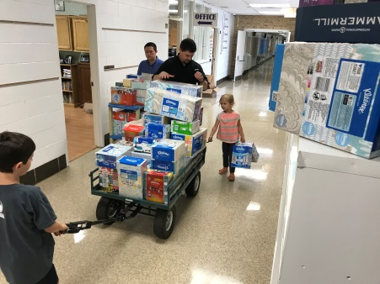
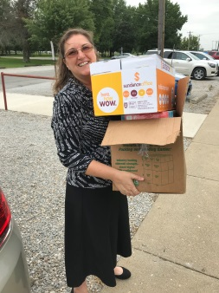

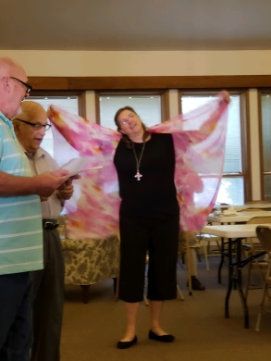
Pancake Breakfast & All Church Sunday School
What a great time was had by all at the Pancake Breakfast the men of the church provided for us on August 19! A great big THANK YOU goes out to Gene Whitton for coordinating, Bill Weaver for teaching Sunday School, Bill Brewer and Ralph Fitch for leading us in song and all the men who helped, shop, cook, serve and clean! We look forward to the next one!

Back-to-School Sunday
Join us in worship as we celebrate with the kids the progress they make in school, letting them know that they have a supporting church that will always be there for them. Bring the whole family, friends, neighbors, or just come by yourself as a family of 1! Also bring a dish to share and some markers for a pot-luck lunch and a fun activity after worship.

Popcorn Worship
On September 2 all our worship activities will be moved to the Popcorn Festival in the Park. Come help serve or eat breakfast at the CFCC church booth and then bring your lawn chair and join us at 10:00 am for the ecumenical community worship service, sponsored by the Casey Ministerial Association, at the Bandstand in the Park. If you want to play in the String choir, they are practicing on September 1 at United Methodist Church. If you want to play or help song lead with the band they are practicing on August 27, August 30, and September 1 at 6:00 pm at First Nazarene Church. If you want to help be a greeter, let Jacqueline know.
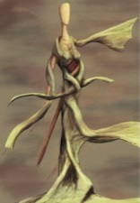
Sermon Series in September
Female Created in the Divine Image of God
September 16 – Woman Wisdom
September 23 – The Competent Wife
September 30 – Women in the Life of Jesus

Calendar
August 26 Back-to-School Sunday: Pot-luck lunch & Fun Church Family Activity
Sept 1-3 Popcorn Festival with the FCC booth
Sept 2 10:00 am Popcorn Worship at the Park (we are moving all Sunday
morning activities to the Park)
Sept 29-30 Women’s Retreat @ Camp Walter Scott
Oct 19-20 Regional Assembly
Nov 3 Thrive! workshop
Nov 10-16 Mission Trip to Little Rock, Arkansas
September Birthdays & Anniversaries

3 Donna Nichols 12 Frances Hickox
3 Debi Sinclair 13 Rhett Athey
5 Connie Roberts 16 Bonnie McCash
5 Tyler Bland 16 Ron & Sharon Rue
5 Sharon Richardson 17 Andy & Erin Leichty
5 John & Cassie Ramsey 18 Alisha Freeman
6 Wade Roberts 18 Corey Carver
7 Larry Smith 18 Mike & Debbie Leichty
9 Daniel Daugherty 18 Jason & Dinah Wimbley
10 Shirley Whitton 22 Bentley Newlin
11 Shirley Fitch 25 Grey Gilbert
11 Wren Roberts
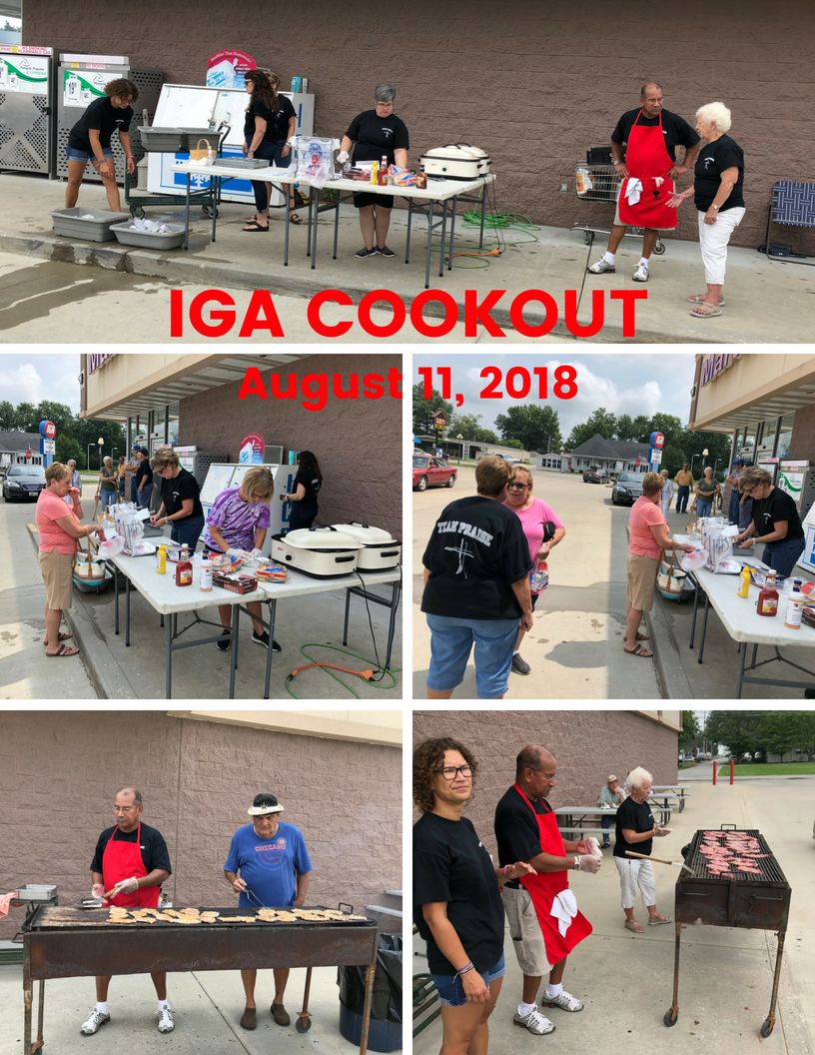
 | September 2018
Sun | Mon | Tue | Wed | Thu | Fri | Sat
1
Popcorn Festival
2  Popcorn Festival  10:00 am Church in the Park | 3 Labor Day  Popcorn Festival  No School | 4 | 5  7:00 Board Meeting | 6 | 7 | 8
9 | 10  9:00 MML  4:30 B/S  5:30 WW | 11 | 12 | 13  5:00 Red Hawk  6:00 Pastoral Care Meeting | 14 | 15
16 | 17  9:00 MML  4:30 Free Meal-Everyday Angels  5:30 WW | 18 | 19 | 20 | 21 | 22 Fall begins
23 | 24  9:00 MML  No School  4:30 B/S  5:30 WW | 25 | 26  7:00 Elders Meeting | 27 | 28 | 29  11:00-1:00 Cookout at IGA  Women’s Retreat
30  Women’s Retreat  6:00 pm Fifth Sunday Sing at First Christian | MML-Monday Morning Ladies  B/S-Boys Scouts  WW-Weight Watchers

