Casey First Christian Church (Disciples of Christ)
200 SE 8th St. · P.O. Box 303 · Casey, IL 62420
(217)932-2773 · cfcc@caseyfcc.org · www.caseyfcc.org

Sunday Services: 9:00 am Sunday School · 10:00 am Worship

To Know God-To Love God-To Serve God

SERVING SCHEDULE
 | Week  11/3/2019 | Week  11/10/2019 | Week  11/17/2019 | Week  11/24/2019 | Week  12/01/2019
ELDERS | Sharon Durham | Nina Meeker | Moe Wimbley | Ruthie Wimbley | Debi Sinclair
ELDERS SHUT-INS | Sharon Durham |  |  |  | Debi Sinclair
DEACONS | Jeri Bland  Bill Brewer  Brad Hickox | Charles Meeker  Cassie Ramsey  Sharon Richardson | Connie Roberts  Kenny Shobe  Steph Shobe | Shellie Simpson  Devan Smith  Cheryl Stifal | Jeanne Unzicker  Jeri Bland  Bill Brewer
PREP. COMM. | Jeanne & Jeri | Charles & Cassie | Sharon & Connie | Shellie & Devan | Jeanne & Jeri
DEACONS SHUT-INS | Jeanne & Jeri |  |  |  | Jeanne & Jeri
WORSHIP LEADER | Larry Patchett | Sherri Butcher | Ruthie Wimbley | Devan Smith | Larry Patchett
GREETER | Marsha Rue | Linda Coleman & Debi Sinclair | Barb Decker | Larry Patchett | Linda Stoneking
SOUND | Devan Smith | Ken Whitton |  | Brad Hickox | Devan Smith
CHILDREN'S MESSAGE | Nina Meeker | Rev. Mike | Rev. Mike | Rev. Mike | Rev. Mike
CHALLENGER REFRESHMENTS | Linda Stoneking | Sherri Butcher | Linda Coleman | Sharon Durham | Grahams
SERMON | Rev. Rebecca Nevius | Rev. Mike Dixon | Rev. Mike Dixon | Rev. Mike Dixon | Rev. Mike Dixon
PLEASE FIND A REPLACEMENT IF YOU ARE NOT ABLE TO SERVE.
UPDATED SERVING SCHEDULES ARE ON THE TABLE IN THE GATHERING ROOM.
Prayer Requests
Patty Clapp
Larry Cutright
Barb Decker
Cecil Dixon – Rev. Mike’s Dad
Stella Donaldson – Barb Decker’s Sister
Ralph & Shirley Fitch
Donna Hacker, Nina Meeker’s Sister, Diagnosed with ALS
Bridget Hensiek
Tony Higginbotham
Vera Ingle
Liza Marie Johnson – Baby Daughter of Andy & Kelly Johnson, Granddaughter of Mike & Cathy Sherwood
Neomi Leohr
Lawrence McKinney
Randy Rue
Arden Shaffner
Shawn Stifal & his Family-He will be having surgery early in November
Jan Stoutin

Our Sympathy and Condolences to the following families that lost loved ones this past month.

Fred Hain Family
Marilyn (Brandenburg) Larkin Family
Dave Sauer Family

JOYS
Birth of twin great grandsons to Janice Richardson and Gene & Shirley Whitton
Keep the twins in your prayers, they are premature.

Casey Health Care Heartland Nursing Active Military
Ruth Fitch & Rehabilitation Tyler Rue
Vera Ingle
Arbor Rose Memory Care Helen Allen
Brenda Whitton Allen Boyd

Announcements & Upcoming Events

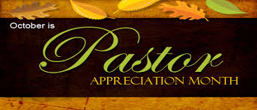
WE NEED TO PRAY FOR OUR PASTORS.

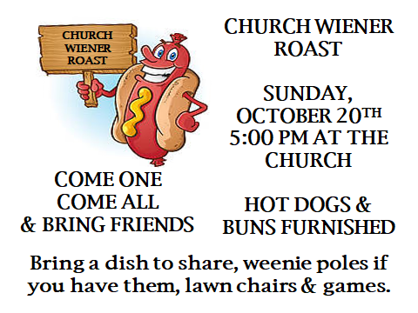

Casey’s Trick or Treat night is Thursday, October 31st
5:30 pm to 8:00 pm
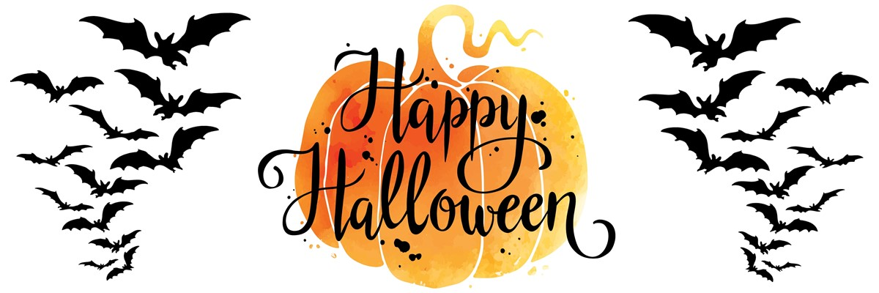
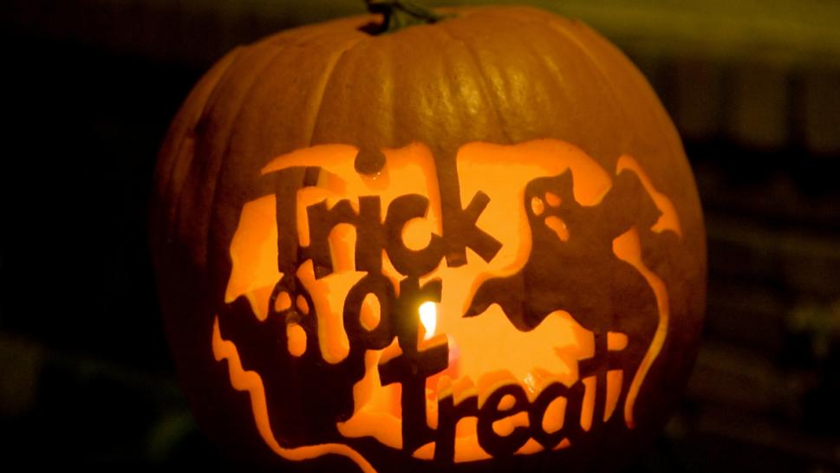

11th Annual Harvest Gift Gathering
And Silent Auction
When: Saturday, November 2, 2019
Time: 9:00 am – 2:00 pm
Where: Trinity Lutheran Church
Fellowship Hall, Casey
Corner of 2nd Street & Colorado Ave.
Lunch Available: 11:00 am – 1:00 pm
For more information contact:
Susan Weir at 932-5401

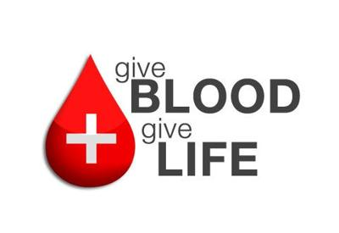
Tuesday, November 5th
12:00 pm – 6:00 pm
Casey First Christian Church
Fellowship Hall
“SPREAD THE WORD”
NOVEMBER 10TH DURING THE 10:00 AM WORSHIP SERVICE
THE OPEN HEART QUARTET
WILL BRING OUR WORSHIP SERVICE IN MUSIC
THEY ARE FROM THE BEDFORD, INDIANA AREA
Open Heart Quartet is a group of Christian men who love the Lord with all their heart and it comes through in the music that they sing. Each song ministers in its own special way with harmonies that are so anointed and powerful. To God be glory!
PLEASE COME JOIN US SUNDAY MORNING, NOVEMBER 10TH
AND BRING YOUR FAMILY & FRIENDS!

ACTIVITIES IN THE CHURCH

Oct 20 5:00 pm Church Wiener Roast
Oct 24 9:30 am Worship Team Meeting
Oct 30 7:00 pm Elders Meeting
Oct 31-Nov 2 Clapp/Glidewell Decorating, Rehearsal & Wedding
Nov 3 Time Change, FALL BACK, turn your clocks back 1 hour
Nov 5 12:00 – 6:00 pm Blood Drive here at CFCC
Nov 6 7:00 pm Board Meeting
Nov 9 Fellowship Hall – Burris Family Reunion
Nov 10 10:00 am Morning Worship - Open Heart Quartet
Nov 11 Veterans’ Day – Church Office Closed
Nov 13 6:30 pm Dinner & A Prayer
Nov 17 Congregational Meeting
Nov 17 All Church Thanksgiving Dinner after worship services, Bring a covered dish or dessert to share.
Nov 20 7:00 pm Elders Meeting (Date change due to Thanksgiving)
Nov 28 Thanksgiving Day – Church Office Closed
Nov 29 Church Office Closed

November 2019

2 – Max Freeman 21 – Marcia Vidoni
3 – Rachel Weger 22 – Laney Gowin
7 – Janice Richardson 23 – Darlene Winn
10 – Alisha (Bland) Wright 23 – Bruce & Deb Decker
11 – Sandy Weaver 24 – Larry & Mary Lou Patchett
13 – Dorothy Stice 24 – Gene & Shirley Whitton
15 – Bentlei Freeman 25 – Mike Sherwood
18 – Brent & Patty Clapp 25 – Ryan Newlin
19 – Macey Brewer 26 – Dustin Weger
19 – Mallory Brewer 26 – Ralph & Shirley Fitch
20 – Brian & Laura McCreanor 27 – Jeanne Unzicker
20 – Gene & Marcia Vidoni 30 – Blake Graham
21 – Cassie Ramsey

 | November 2019
Sunday | Monday | Tuesday | Wednesday | Thursday | Friday | Saturday
 |  |  |  |  | 1  Wedding  Rehearsal  Clapp/  Glidewell | 2  Wedding  Clapp/  Glidewell
3  Time Change-Fall Back One Hour | 4  MML  9:00 AM | 5  12:00-6:00 pm Blood Drive | 6  7:00 pm Board Mtg. | 7 | 8 | 9  FH– Burris Family Reunion
10  10:00 am  Open Heart Quartet during worship | 11  MML  9:00 AM  Veterans Day  Office Closed | 12 | 13  6:30 pm  Dinner & A Prayer | 14 | 15 | 16
17  Congregational Meeting  Thanksgiving Dinner after worship | 18  MML  9:00 AM | 19 | 20  **7:00 pm  Elders Mtg. | 21 | 22 | 23
24 | 25  MML  9:00 AM | 26 | 27 | 28  Thanksgiving Day  Office Closed | 29  Church Office Closed | 30
MML – Monday Morning Ladies
FH – Fellowship Hall
Sunday School 9:00 am, Worship 10:00 am
**Elders Meeting Date Change Due To Thanksgiving

