Casey First Christian Church (Disciples of Christ)
200 SE 8th St. · P.O. Box 303 · Casey, IL 62420
(217)932-2773 · cfcc@caseyfcc.org · www.caseyfcc.org
Office Hours: Monday, Wednesday & Friday 8:30 am-Noon

Sunday Services: 9:00 am Sunday School, 10:00 am Worship

To Know God-To Love God-To Serve God

Prayer Requests
Larry Patchett Randy Rue Cindy Wimbley
Ron Bayles Alan Ingle Fiona Stifal
Gene Whitton Lynda Graham Nancy West
Arlene Green Sharon Roberts Mona & Gary Moore
Liz Wemple Mike Suliver

Our Sympathy and Condolences to the following family that lost a loved one since the last newsletter.

Family of Benny Stutesman Family of Gary Littlejohn Family of Betty Brewer

Casey Health Care Heartland Nursing Simple Blessings
Ruth Fitch & Rehabilitation Ramona Miller
Vera Ingle
Helen Allen

Please reach out to your Elder with any questions, concerns or needs.
2021 ELDERS
Sherri Butcher – 217-232-5740 Sharon Durham – 217-232-2168
Kathy Hayes – 217-932-3626 Peggy Hickox – 217-232-5615
Nina Meeker – 217-549-9808 Larry Patchett – 217-232-3105 Moe Wimbley – 217-232-3530 Dan Winn – 217-259-5339 Church Office – 217-932-2773(Hours: Mon, Wed & Fri 8:30 am – Noon)

Announcements & Upcoming Community Events

September 29th, Wednesday, 6:30 pm Elders Meeting
October 3rd, Sunday World Communion Sunday & Reconciliation Special Offering
October 6th, Wednewday, 9:30 am Worship Team Meeting
October 6th, Wednesday, 7:00 pm Special Board Meeting
October 11th, Monday, 6:30 pm Circle of Grace in Sharing Grief
October 27th, Wednesday, 6:30 pm, Elders Meeting
October 31st, Sunday during worship, OPEN HEART QUARTET

ELDERS FOR OCTOBER –3rd Sharon Durham, 10th Kathy Hayes, 17th Peggy Hickox, 24th Nina Meeker, 31st Moe Wimbley

DEACONS FOR OCTOBER – 3rd Jenny Winschief, Darlene Winn, Jeanne Unzicker, 10th Shellie Simpson, Kenny Shobe, Steph Shobe, 17th Devan Smith, Cathy Sherwood, Cassie Ramsey, 24th Brad Hickox, Lynda Graham, Bill Brewer, 31st Jenny Winschief, Darlene Winn, Jeanne Unzicker

GUEST SPEAKERS FOR OCTOBER- 3rd Kyle Simpson, 10th Terri Smith, 17th ???, 24th Rev. Mike Dixon, 31st Open Heart Quartet

Challenger Refreshments for October – 3rd Peggy Hickox, 10th Larry Patchett, 17th Cathy Sherwood, 24th Debi Sinclair, 31st Linda Stoneking

THE NOMINATING COMMITTEE IS WORKING ON 2022 OFFICERS.
IF YOU WOULD LIKE TO VOLUNTEER FOR AN OFFICE OR NOMINATE SOMEONE FOR AN OFFICE PLEASE CONTACT A MEMBER OF THE NOMINATING COMMITTEE.
Marge Allen, Barb Decker, Donna Nichols, Devan Smith or Dan Winn

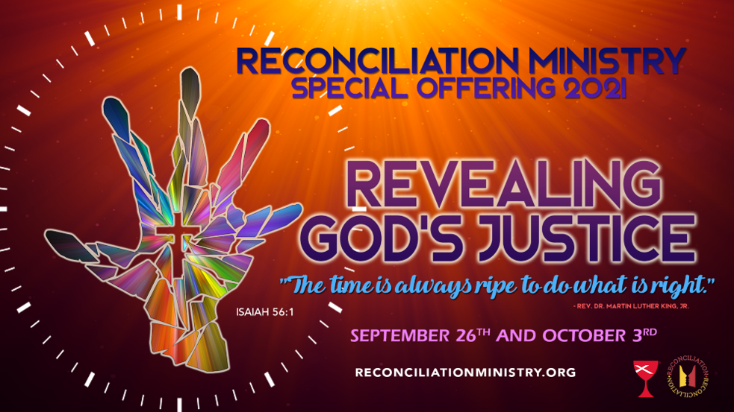

OCTOBER 2021

4 – Kora Smith 19 – Curtis & Karen Carver
6 – Jason Clapp 24 – Ralph Fitch
9 – Dennis & Marsha Millam 26 – Ashton Newlin
11 – Brock Athey 29 – Mike Leichty
13 – Echo Sherwood

 | OCTOBER 2021
Sunday | Monday | Tuesday | Wednesday | Thursday | Friday | Saturday
 |  |  |  |  | 1 | 2
3  Elder: Sharon Durham  World Communion Sunday | 4  MML  9:00 am | 5 | 6  Worship Team Mtg. 9:30 am  Special Board Mtg. 7:00 pm | 7 | 8 | 9
10  Elder: Kathy Hayes | 11  MML  9:00 am  Circle of Grace 6:30 pm | 12 | 13 | 14 | 15 | 16
17  Elder: Peggy Hickox | 18  MML  9:00 am | 19 | 20 | 21 | 22 | 23
21  Elder: Nina Meeker | 25  MML  9:00 am | 26 | 27  Elders Mtg. 6:30 pm | 28 | 29 | 30
31  Elder: Moe Wimbley  OPEN HEART QUARTET |  | FH – Fellowship Hall  MML – Monday Morning Ladies  SUNDAYS  9:00 am Sunday School, 10:00 am Worship

