Casey First Christian Church (Disciples of Christ)
200 SE 8th St. · P.O. Box 303 · Casey, IL 62420
(217)932-2773 · cfcc@caseyfcc.org · www.caseyfcc.org
Pastor Evan Sherar, 812-698-7504, pastor.evansherar@gmail.com
Pastor Office Hours: Monday10 am-4 pm, Tues-Thurs 9 am-2 pm
Secretary Office Hours: Wednesday 8:00 am - Noon
Sunday Services: 9:00 am Sunday School, 10:00 am Worship

To Know God-To Love God-To Serve God

Greetings Church!

In this season of Lent, we have an opportunity to reflect on our humanity and on the Good News of Jesus. Here’s a poem I wrote about this Good News, and at the end of it I’ve included references to the many verses of scripture that I drew from. I call this poem:

Putting Bad Theology to Death

It is not the violence done to Jesus that saves the world;
it is the Love that raised him from the dead.
That Love is the focal point of Christian faith.
Not the “love” of arbitrary sacrifice or so-called redemptive violence.
No, it’s the Love that even violence cannot kill.
It’s the Love that is alive-
the Love that makes us alive.
It is light that darkness cannot overcome.

God is not angry.
Good News is not about appeasing divine wrath
That sounds more like Bad News
and its fruits are fear and shame.
But fear, shame, and wrath are not who God is.
No, God is not angry.
God is not, and never was, mad at you.
Do not share any News bearing wrath, guilt, condemnation, fear, shame, or worse.
God is Love.
Share Love.

Share the Love that will stop at nothing
to understand that which is other than Love-self.
Share that there is no hell so low to which Love will not stoop.
Share Love’s radical solidarity with dark-skinned minorities
who are suffering under violent empire.
Share radical love for neighbors and love for enemies,
what Jesus calls “taking up your cross,”
as a way of reconciling all things to each other and creation to God.
Share Christ and him crucified,
not as bloody atonement but as Love Incarnate;
a foolishness to the powerful and a stumbling block to hegemony,
but freedom and salvation for the rejects and refuse.

It’s time we put Bad News to death.
Hear the Good News: God is Love.

Love does no harm to another,
and thereby Love fulfills all holiness.
Let that same Love,
the Love that raised Christ from the dead,
come alive in your heart and life
and give you peace.
Now to the One who is able to do abundantly far more
than all we could ask or imagine
be glory and honor and praise, now and forever.
May the grace of our Lord Jesus Christ,
the Love of God,
and the communion of the Holy Spirit be always with us. Amen.

Rom 8:11; 2 Cor 4:14; Jn 1:5; Jn 3:17; 1 Jn 4:8, 18; Rom 8:31-39; 11:32; 1 Tim 2:4; Mk 12:28-31; Lk 6:32-36, 10:25-28; Mt 5:43-44, 22:37-40; Mk 8:34; Lk 9:23; Mt 16:24; Col 1:15-22; 1 Cor 2:2, 1:23; Rom 13:10; Eph 3:20-21; 2 Cor 13:13
--
Peace,

Pastor Evan Sherar
Casey First Christian Church (Disciples of Christ)
Casey, Illinois
cell: (812) 698-7504

Prayer Requests
Cindy Wimbley Doris Taylor
Larry Patchett Roberta Ashley
Kenny & Steph Shobe Brandi Chrysler
Bruce & Deb Decker Ralph Fitch, C/O Cumberland Rehab,
Zach Fritcher Rm # 114, 300 N. Marietta St.
The Family of Bob Dillier Greenup, IL 62428

Fred Bright will be celebrating his 95th birthday on March 18th. Please shower him with birthday cards, 502 N.W. 2nd St., Casey. He would really appreciate it.

MARCH SERVING SCHEDULES

ELDERS: 3/5 Debi S, 3/12 Ruthie W, 3/19 Dan W, 3/26 Sherri B
DEACONS: 3/5 Becky S, Jeanne U, Michelle W, 3/12 Jenny W, Lynda G, Brad Hickox,
3/19 Cassie R, Connie R, Sharon R, 3/26 Cathy S, Shellie S, Devan S
CHALLENGER REFRESHMENTS: 3/5 Peggy H, 3/12 Sharon R, 3/19 Cathy S, 3/26 Debi S

Announcements & Upcoming Community Events

March 1, 2023, Monday 6:30 pm Board Meeting
March 2nd & 3rd, Thursday & Friday Preschool Roundup here in the church
March 7, 2023, Tuesday 6:30 pm Bible Study
March 12, 2023, SOUP LUNCH, after church. Fund raiser for Camp Walter Scott
March 13, 2023, Monday, 5:30 pm Dinner & a Prayer
March 14, 2023, Tuesday 6:30 pm Bible Study
March 19, 2023 – “Open Heart Quartet” will be here for our worship service
March 21, 2023, Tuesday 6:30 pm Bible Study
March 27, 28 & 30 – Tote-a-meal Delivery. This is the last week that meals from Heartland Nursing and Rehab will be delivered. Peace Meal will be handling the meal service.
March 28, 2023, Tuesday 6:30 pm Bible Study
March 29, 2023, Wednesday, 9:30 am Worship Team Meeting
March 29, 2023, Wednesday, 6:30 pm Elders Meeting
April 1, 2023, Saturday – FREE GARAGE SALE. Start collecting items you want to
donate.

MARCH 2023

2 – Lynda Graham 18 – Fred Bright
4 – Kay Smith 18 – John Graham
15 – Curt & Jane Wheat 28 – Linda Coleman
17 – Rose Peterson

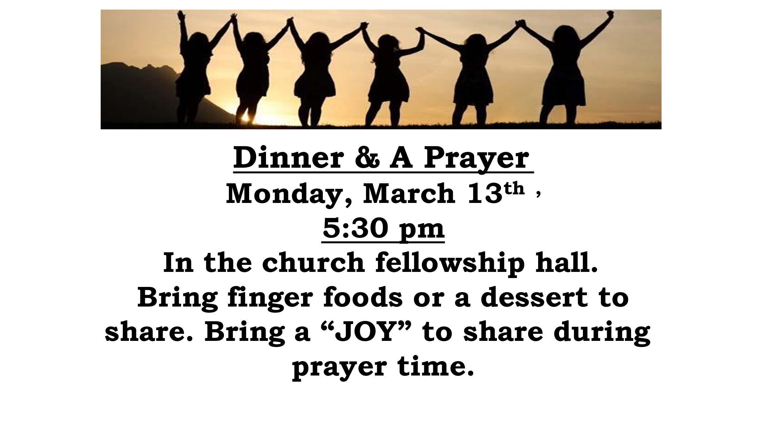
Sunday, March 12th after church. Soup will be provided. Bring something to go along
with the soup to share. A freewill offering
will be collected for Camp Walter Scott.

 | MARCH 2023
Sunday | Monday | Tuesday | Wednesday | Thursday | Friday | Saturday
 |  |  | 1  Board Mtg.  6:30 pm | 2  Preschool Roundup | 3  Preschool Roundup | 4
5  Elder: Debi S | 6  MML 9 am | 7  Bible Study  6:30 pm | 8 | 9 | 10 | 11
12  Elder: Ruthie W  Soup Lunch | 13  MML 9 am  Dinner & a Prayer  5:30 pm | 14  Bible Study  6:30 pm | 15 | 16 | 17 | 18
19  Elder: Dan W  “Open Heart Quartet” | 20  MML 9 am | 21  Bible Study  6:30 pm | 22 | 23 | 24 | 25
26  Elder: Sherri B | 27  MML 9 am  Tote-a-meal | 28  Tote-a-meal  Bible Study  6:30 pm | 29  Worship Team Mtg. 9:30 am  Elders Mtg.  6:30 pm | 30  Tote-a-meal | 31
FH – Fellowship Hall
MML – Monday Morning Ladies
SUNDAYS
9:00 am Sunday School, 10:00 am Worship

