Casey First Christian Church (Disciples of Christ)
200 SE 8th St. · P.O. Box 303 · Casey, IL 62420
(217)932-2773 · cfcc@caseyfcc.org · www.caseyfcc.org
Pastor Evan Sherar, 812-698-7504, pastor.evansherar@gmail.com
Pastor Office Hours: Monday10 am-4 pm, Tues-Thurs 9 am-2 pm
Secretary Office Hours: Wednesday 8:00 am - Noon
Sunday Services: 9:00 am Sunday School, 10:00 am Worship

To Know God-To Love God-To Serve God

There is no hell. Hell is not real.

Normally, I would bury this statement in dense theological discussion, quotes from second and third century Church fathers, or highly systematized references from Scripture. But not today. I don’t want this to get lost in the weeds, or in obscured in flowery language, or watered down by concessions to what may be popular.

It may be that many believe there is a hell, and that if we do not repent from our sin we will end up there - either to be actively tortured forever or passively suffering the eternal loss of being separated from God. I don’t want to be vague on this, or leave anything I’m saying up to interpretation here. It is absolutely essential to my Christian faith that an afterlife hell of eternal, conscious torment or irreparable separation from God forever is anathema. “Anathema” is a big theology word that means I vehemently reject this notion.

Here’s why:
1 John 4:18 says “There is no fear in love, but perfect love casts out fear; for fear has to do with punishment, and whoever fears has not reached perfection in love” (NRSVue). If it causes fear, then it is not love. If any version of the gospel story is centered on punishment, then is not the Good News of Jesus Christ. If your motivation for believing in Jesus is at all based on avoiding Hell, then you’ve missed the whole point.

1 Timothy 2:4 says “[God] desires everyone to be saved and to come to the knowledge of the truth” (NRSVue). If you’re honest at all about who Scripture says God is, then you have to admit that God seems like he is full of compassion and love. There are thousands of verses saying God’s mercy endures forever, or that God’s love is steadfast. Of all the variables in the equation of life, God’s love is a constant. And in this verse in 1 Timothy it is stated almost in passing as a well-known and widely accepted fact that God’s inmost desire is that all shall be saved. I imagine many reading this may have many, many questions because I expect what I am saying might directly contradict what you’ve been taught your whole life. Before I address any of those questions, I want to offer my own. If God wants all to be saved (see 1 Timothy 2:4 above), then at the end of everything, when God’s glory is fully revealed - does God get what God wants?

You may ask, “What about free will? God does not force us to believe in him, does he?” Absolutely not, and I fully agree with you that any so-called “love” that forces its way onto another is not love. Love does not violate consent. Love does not override the freedom of our will. This is essential to Christian faith, and brings us back to the verse with which I began: 1 John 4:18 says “There is no fear in love, but perfect love casts out fear; for fear has to do with punishment, and whoever fears has not reached perfection in love” (NRSVue). Love does not override our free will, but fear does.

Fear makes us do things that go against our nature. Fear controls our behavior. We fear punishment, so we fall in line and do what we’re told. Fear keeps us silent, as if our voices don’t matter. Fear builds walls. Fear makes us hide. Fear closes us off to our neighbors. “I can’t let them in, they’ll hurt me.” Worst of all, fear turns us against each other.

Beware those who would make you afraid. Abusers use fear to control. Empires use fear to exploit. Shame uses fear to divide and conquer - because if we fear each other then we’ll never discover the life-saving power of love! Fear binds our will. With fear, we are never free. Fear keeps us from one another, and it keeps us from God.

But perfect love casts out fear.

The word “perfect” in Scripture refers to completion, to wholeness. When Love is complete and whole, fear cannot exist. The fullness of the glory of God cannot co-exist with fear. Perfect love casts out fear - it makes fear be no more. When Love makes us whole, we are no longer bound by fear. Love does not violate our free will, but rather it is Love that makes our will free.

The Good News of Jesus is not “Obey, or face endless violence in outer darkness for all eternity.” The Good News of Jesus Christ, who loves us and saves us, who desires that all shall be saved, is this:

“Fear not, for I have overcome.”

There is no hell. It is not real. And even if there was a hell, we should not fear it. Fear is anathema to the gospel of Jesus Christ. Instead, we have this unshakable hope that the One who began a good work in us will see it to completion (see Philippians 1:6). The One who calls you is faithful, he will see to it (see 1 Thess 5:24), because it is God’s eternal will that all shall be saved.

Peace,

Pastor Evan Sherar

Prayer Requests
Larry Patchett Doris Taylor
Kenny & Steph Shobe Ralph Fitch
Bruce & Deb Decker Brandi Chrysler
Arlin & Brenda Cortelyou Family of Shirley Athey
Gary Kuhn Bill Crouch

APRIL SERVING SCHEDULES

ELDERS: 4/2 Sharon D, 4/9 Kathy H, 4/16 Peggy H, 4/23 Nina M, 4/30 Debi S
DEACONS: 4/2 Cheryl S, Becky S, Jeanne U, 4/9 Michelle W, Jenny W, Lynda G,
4/16 Brad H, Cassie R, Connie R, 4/23 Sharon R, Cathy S, Shellie S, 4/30 Devan S, Cheryl S, Becky S
CHALLENGER REFRESHMENTS: 4/2 Linda S, 4/9 Sherri B, 4/16 Linda C, 4/23 Sharon D, 4/30 Grahams

Announcements & Upcoming Community Events

March 29, 2023, Wednesday, 9:30 am Worship Team Meeting
March 29, 2023, Wednesday, 6:30 pm Elders Meeting
April 2, 2023 PALM SUNDAY
April 2nd & 9th Sundays, SPECIAL EASTER OFFERINGS
April 4, 2023, Tuesday, 7:00 pm Bible Study
April 5, 2023, Wednesday, 6:30 pm Board Meeting
April 6, 2023, Thursday, 6:30 pm Maundy Thursday Service
April 9, 2023, Sunday EASTER SUNDAY, Sunrise at 7:30 am, Breakfast to follow, Sunday School 9:00 am, Worship 10:00 am
April 10, 2023, Monday, 6:00 pm Dinner & a Prayer (Note time change)
April 11, 2023, Tuesday, 7:00 pm Bible Study
April 15, 2023, Saturday – FREE GARAGE SALE. Start collecting items you want to
donate.
April 18, 2023, Tuesday, 7:00 pm Bible Study
April 25, 2023, Tuesday, 7:00 pm Bible Study
April 26, 2023, Wednesday, 6:30 pm Elders Meeting

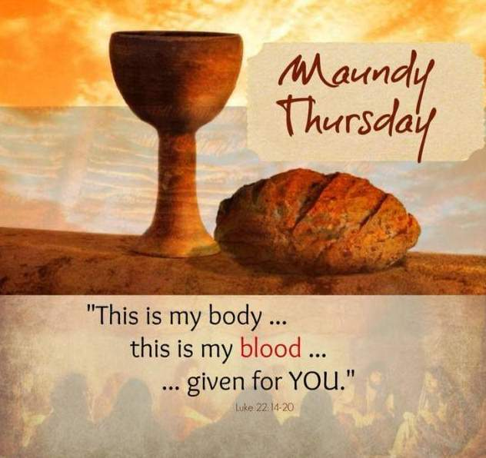

APRIL 2023

2 – Gene Vidoni 13 – Danny & Shellie Simpson
7 – Devan Smith 15 – Sharon Rue
11 – John & Lynda Graham 17 – Tony & Sherri Butcher
12 – Marsha Rue 23 – Billy & Tricia Garver

 | APRIL 2023
Sunday | Monday | Tuesday | Wednesday | Thursday | Friday | Saturday
 |  |  |  |  |  | 1
2  Elder: Sharon D | 3  MML 9 am | 4  Bible Study  7:00 pm | 5  Board Mtg.  6:30 pm | 6  Maundy Thursday Service 6:30 pm | 7 | 8
9  Elder: Kathy H | 10  MML 9 am  Dinner & a Prayer  6:00 pm | 11  Bible Study 7:00 pm | 12 | 13 | 14 | 15  Free Garage Sale
16  Elder: Peggy H | 17  MML 9 am | 18  Bible Study  7:00 pm | 19 | 20 | 21 | 22
23  Elder: Nina M | 24  MML 9 am | 25  Bible Study  7:00 pm | 26  Elders Mtg.  6:30 pm | 27 | 28 | 29
30  Elder: Debi S |  | FH – Fellowship Hall  MML – Monday Morning Ladies  SUNDAYS  9:00 am Sunday School, 10:00 am Worship

