Casey First Christian Church (Disciples of Christ)
200 SE 8th St. · P.O. Box 303 · Casey, IL 62420
(217)932-2773 · cfcc@caseyfcc.org · www.caseyfcc.org

Secretary Office Hours: Wednesday 8:00 am - Noon
Sunday Services: 9:00 am Sunday School, 10:00 am Worship

To Know God-To Love God-To Serve God

Prayer Requests
David Hickox Dick Wheeler Kenny & Steph Shobe
Kenny’s Kidney Donor Keith Sinclair Dan Winn
Larry & Lance Patchett Deb Decker
Family of Scotty Millam Family of Dick Maulding Family of Phil Reeds

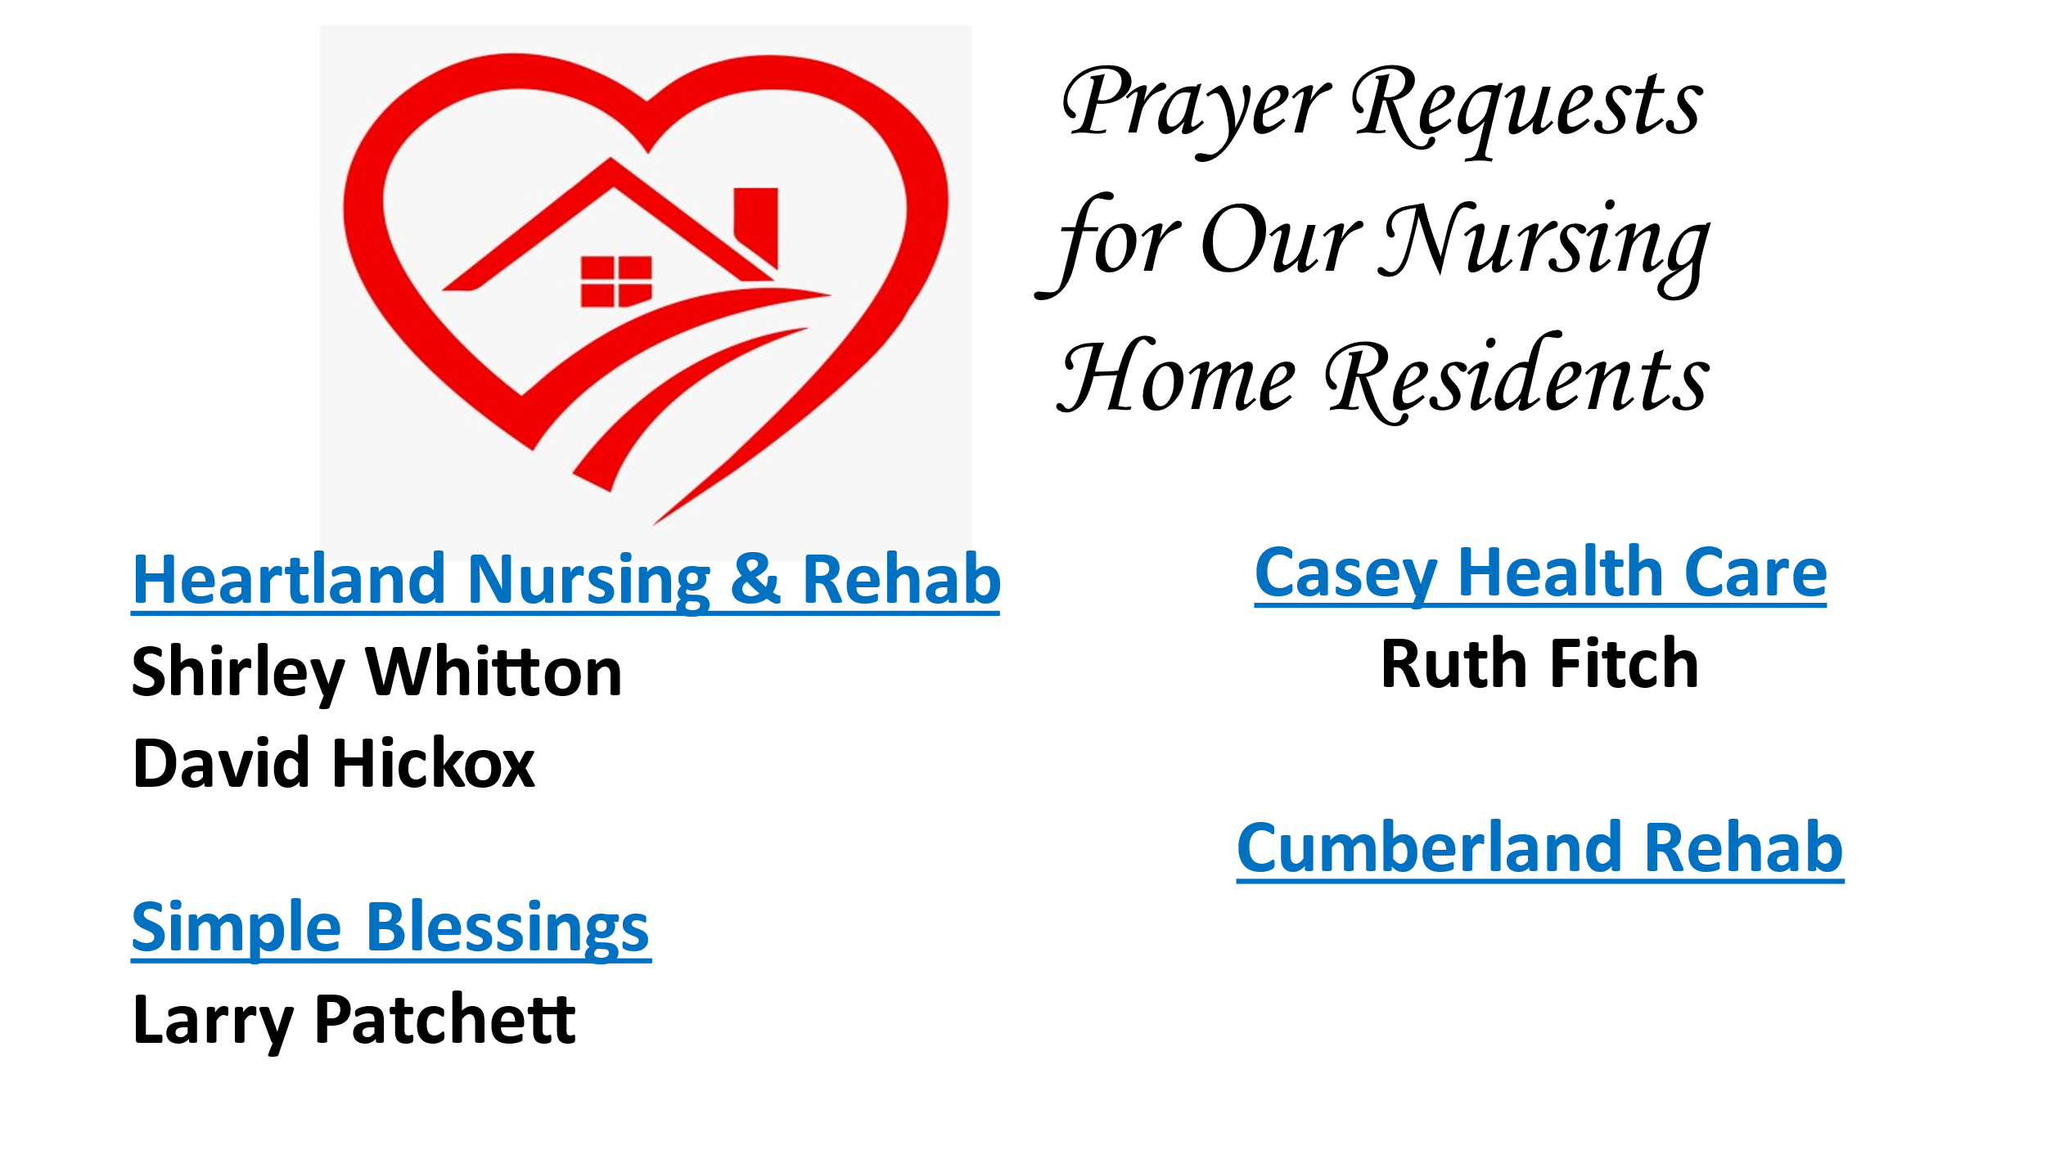

OCTOBER SERVING SCHEDULES

ELDERS: 10/1 Kathy H, 10/8 Peggy H, 10/15 Nina M, 10/22 Debi S, 10/29 Ruthie W
DEACONS: 10/1 Shellie S, Devan S, Cheryl S, 10/8 Becky S, Jeanne U, Michelle W,
10/15 Jenny W, Lynda G, Brad H, 10/22 Cassie R, Connie R, Sharon R, 10/29 Cathy S, Shellie S, Devan
CHALLENGER REFRESHMENTS: 10/1 Sharon R, 10/8 Cathy S, 10/15 Debi S, 10/22 Linda S, 10/29 Sherri
SOUND TECHS: 10/1 Cathy, 10/8 Dyson, 10/15 Brad, 10/22 Dan, 10/29 Kenny
GUEST SPEAKERS: 10/1 Adam Solorio, 10/8 Coach Jeff Fritchtnitch, 10/15 Rev. Mike Dixon,
10/22 Steve Jenkins, 10/29 ??
Announcements & Upcoming Community Events

October 4, 2023 – Wednesday, 6:30 pm Church Board Meeting
October 6, 2023 – Friday Evening Clark County 4H Awards Night
Here at the church
October 18, 2023 – Wednesday, 10:00 am Worship Team Meeting
October 20, 2023 – Friday, Church of Casey Special Service
October 25, 2023 – Wednesday, 7:00 pm Elders Meeting

October

4 – Kora Smith 9 – Dennis & Marsha Millam

 | OCTOBER 2023
Sunday | Monday | Tuesday | Wednesday | Thursday | Friday | Saturday
1  Elder: Kathy H | 2  MML 9 am | 3 | 4  Board Mtg.  6:30 pm | 5 | 6  Clark Co.  4H Awards | 7
8  Elder: Peggy H | 9  MML 9 am | 10 | 11 | 12 | 13 | 14
15  Elder: Nina M | 16  MML 9 am | 17 | 18  Worship  Team Mtg.  10 am | 19 | 20  Church of Casey Special Service | 21
22  Elder: Debi S | 23  MML 9 am | 24 | 25  Elders Mtg.  7 pm | 26 | 27 | 28
29  Elder: Ruthie s | 30  MML 9 am | 31
FH – Fellowship Hall
MML – Monday Morning Ladies
SUNDAYS
9:00 am Sunday School, 10:00 am Worship

